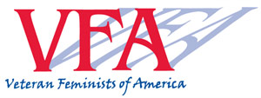

VFA Pioneer Histories Project – Interview Questions

- Name
- What was your life like before you got involved in the women’s movement? (Include ethnic background)
- How did you get involved in the movement?
- What year was that?
- Where and when were you active in the women’s movement?
- What was your involvement? What organization, if any? What was your role(s)?
- What issues were of greatest concern to you?
- What were your major accomplishments - personally and that you were involved with?
- What were your most memorable and important experiences?
- How has your involvement in the movement affected your later life (personally and professionally)?
- Have you been involved as an activist in the women’s movement or other areas since your Second Wave experience?
- Are you currently involved as an activist?
- Anything else relevant we haven’t covered?

